Start Morning:

if Saturday:

    going in fishing:

else if Sunday:

   read a book:

else:

   going   work:

End:

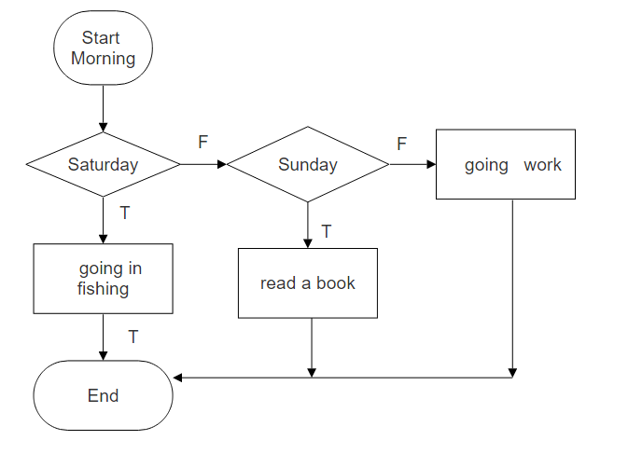

1.

Start Morning:

if Saturday:

    if time < 13:00:

      going in fishing:

   else if time = 18:00

      watch football:

else if Sunday:

     while time < 15:00:

       read a book:

     else:

       watch TV:

else:

   going   work:

End:

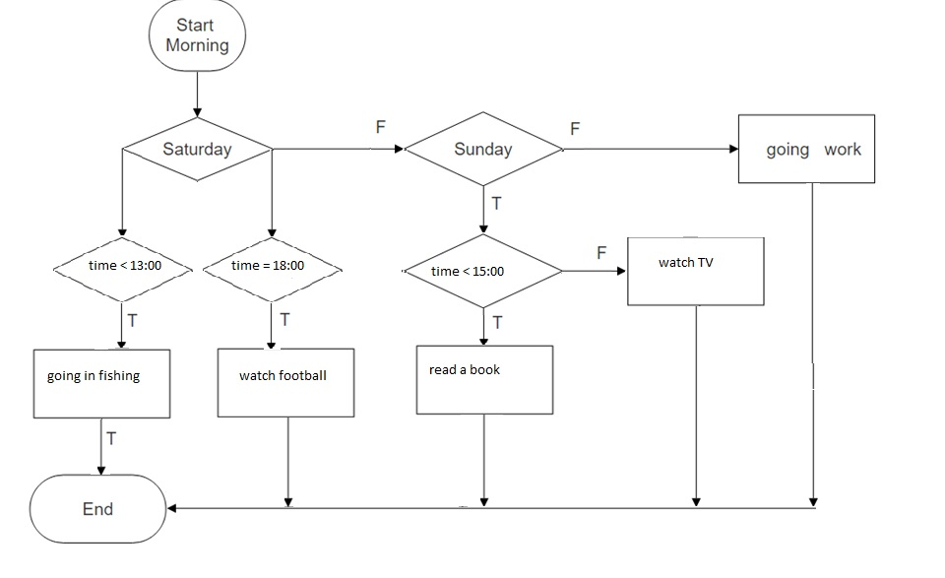

2.

Start:

if time=13:00:

    start lunch:

else if time = 14:00:

    end lunch:

else:

   while time<18:00

     if time = 16:00:

       meeting:

     else:

      work:

   else:

     home:

End:

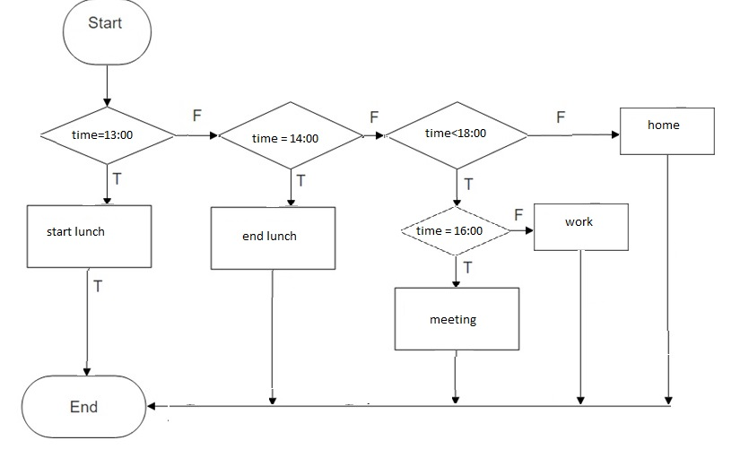

3.

Start: A, B, C

if A+B\*C>100:

A=B:

C=10:

while A>0:

A=A-1:

Else C=B+1:

End:

